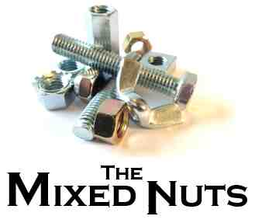
Rock N’ Roll Set
Last revised on 2017.07.30

RR01-Great Balls Of Fire(KVF).2017.07.11.pdf
RR01-Great Balls Of Fire(KVM).2017.07.11.pdf
RR02-Smoke On The Water(KVD).2017.07.30.pdf
RR03-Rock Medley 4-Whole Lotta Shakin' Goin' On, Shake Rattle,
& Roll, All Shook Up.2017.07.11.pdf
RR04-Peggy Sue(KVD).2017.06.04.pdf
RR05-Jailhouse Rock(KVF).2017.07.11.pdf
RR05-Jailhouse Rock(KVM).2017.07.11.pdf
RR06-Rock Medley 1-La Bamba, Surfin' USA,
Let's Twist Again.2017.07.12.pdf
RR07-Hotel California(KVD).2017.07.30.pdf
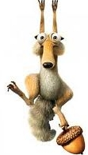
RR08-Johnny B. Goode(KVF).2017.07.11.pdf
RR08-Johnny B. Goode(KVM).2017.07.11.pdf
RR09-Kansas City(KVF).2017.06.04.pdf
RR09-Kansas City(KVF).2017.06.04.pdf
RR09-Kansas City(KVM).2017.06.04.pdf
RR10-Rock Medley 2-Ticket To Ride, Old Time Rock & Roll,
Twist And Shout.pdf
RR11-Proud Mary(KVD).2017.06.04.pdf
RR12-Wooly Bully(KVD).2017.07.11.pdf
RR13-Rock Medley 3-Blue Suede Shoes, Peppermint Twist,
Rock Around The Clock.2017.07.11.pdf
RR14-I Heard It Through The Grapevine(KVD).2017.07.30.pdf
RR14-I Heard It Through The Grapevine(VOCAL).2017.07.30.pdf
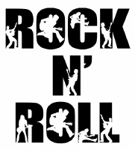
RR15-Walk Like A Man(KVD).2017.07.11.pdf
RR16-Hound Dog(KV).2017.06.04.pdf

